How to Plan your Facebook Ads Campaign
Updated: October 1st, 2021
Execution Time: 30 mins - 1h

Goal: To get a clear, visual, high-level document that everyone will understand, and that illustrates how your Facebook Ads and funnel are structured.

Ideal Outcome: You have a simple diagram that you can use to plan your campaigns before launching them.

Prerequisites or requirements: You need to have a clear idea regarding how your funnel works and its different stages and a Google account.

Why this is important: Making changes on your Google Drawings template is much easier than doing them once they are already live on Ads Manager, besides that you get a clear picture on what’s overlapping and what’s missing.

Where this is done: In Google Drawings.

When this is done: Every time you’re starting a large Facebook Ads campaign.

Who does this: The person responsible for Facebook Ads media buying.

Environment setup

- Click on the image link below and “Get a copy” of the “Funnel Designer Tool” below:

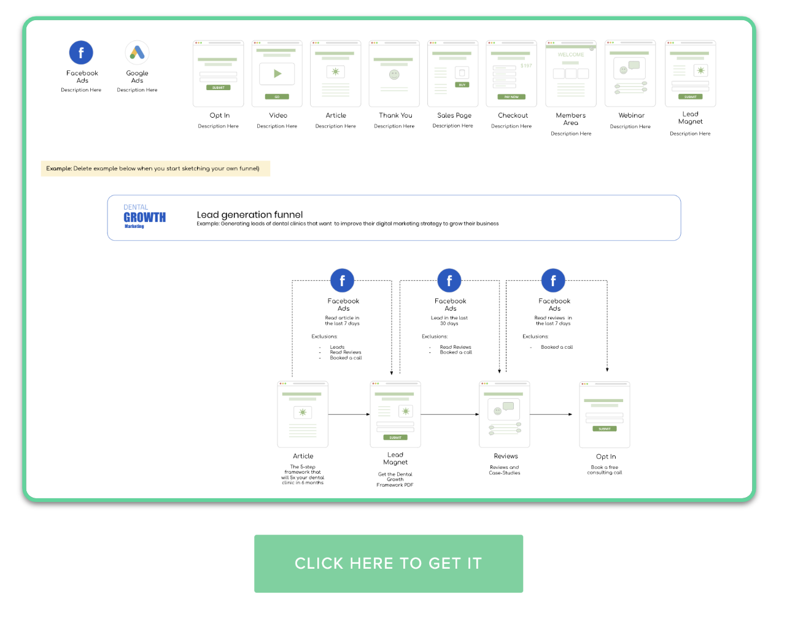

Design your current funnel

Adding new elements: You can drag and drop elements to the canvas as long as you click and hold the ‘Option’ key (Mac OS) on your keyboard while dragging. This will automatically create a copy of that element for you to use.

Connecting elements:
- Click the line selection tool on the top, and select ‘Arrow’:

- Connect all your elements as you see fit:

Note: Need more elements? Send a request to hello@clickminded.com;

Planning your Ads

- Sketch your current funnel using the template:



- For each stage of the funnel, you will want to consider if it makes sense to drive:

  - Cold Traffic - Allows you to reach new audiences and scale your business.
    - Note: The content that you share with cold traffic is typically top-of-the-funnel (TOFU) content—blog posts, podcasts, videos, etc. (There are rare cases when your middle-of-the-funnel (MOFU) or bottom-of-the-funnel (BOFU) content might work well with cold traffic, feel free to experiment with that if you are unsure.)

  - Warm/Hot Traffic (Remarketing) - Allows you to reach audiences that have already been to your website, and push them down the funnel.
    - Note: These audiences are usually cheaper to engage and closer to purchasing than cold traffic. Since these people are already familiar with your content, you might consider sending them MOFU (lead magnets, tripwires, downloadables, free trials) or BOFU (limited time offers, testimonials, coupons) content.

  - None - Sometimes you might not want to do anything at a specific stage of the funnel, and that’s alright.

Important: To better select the Facebook audiences to use (no matter if Cold, Warm or Hot) have SOP074 - How to select your Facebook ads Ad Set targeting by your side.

- Add Cold Traffic elements to your funnel: Cold Traffic usually performs better with TOFU content, this is especially true if your main offer is a premium-priced product. (There are rare instances when your MOFU or BOFU might work well with cold traffic, feel free to experiment with that if you are unsure.) So if you are unsure, start adding cold traffic to the first stages of your funnel.


- Add Warm/Hot traffic elements to your funnel: For remarketing, ideally, you should use ads to push people through each stage of the funnel. But if the size of your audience is too small you might not be able to do that, if that is the case you might want to group a few of those within a single Ad Set instead.
  - Example: If any of the stages of your funnel has less than 100 people in the audience within the period that you’ll be targeting them, you will not be able to run an ad just for them. In that case, consider running an ad that targets people on a few other stages of your funnel as well until you reach an audience that is larger than 100 people (ideally, aim for 5,000 people or more while keeping the relevancy of your ad and audience).


- That’s it! You now have a high-level overview of how your Ads will look like.

- If you want to download it as an image to print or send to other people click File → Download as → PNG image (.png) :

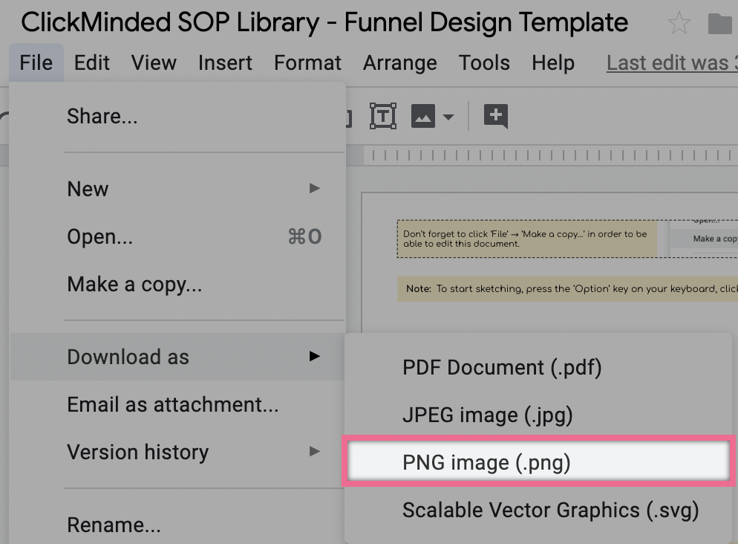

- If you want to share it with other people inside Google Drawings, click File → Share and select your sharing options.

